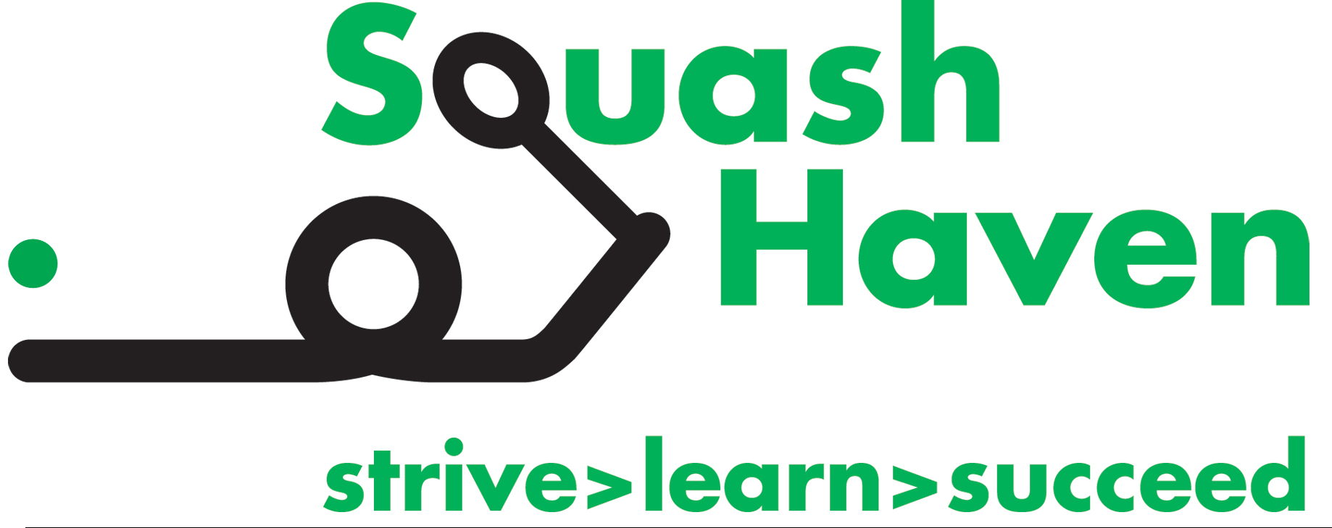

Squash Haven is a youth development program which uses the sport of squash, in combination with
academic tutoring, literacy development, fitness education, community service, college access, and career development to empower and make a lasting difference in the lives of New Haven young people. Team members thrive in our kid-centered environment that also features individual relationships, a close and collaborative staff and inclusive culture. Founded in 2006, Squash Haven has grown from one staff and 20 kids to an inspiring community of 160 students in 5th grade through college graduates as well as a full time staff of seven.

The Squash Coordinator Opportunity: Squash Haven seeks an enthusiastic, hardworking, and growth-minded candidate with strong squash playing and/or coaching experience and a desire to pay that love of sport forward. Squash Haven has one of the strongest squash programs in the Squash and Education Alliance (SEA), with 50% of team members going on to play college squash. Access to Yale’s facility as well as volunteer coaching by the Yale teams make this a very desirable professional opportunity. In close partnership with Director of Squash John DeWitt, the Coordinator will have the following responsibilities:

- Lead daily squash/fitness sessions during after-school hours and weekends
- Supervise all squash coaching volunteers, including Yale teams
- Develop long-term squash and fitness training plans which will inform daily lessons/practices
- Manage squash equipment and uniforms for all program participants
- Oversee tournament selections & enrollment as well as US Squash memberships and SEA-related activities
- Ensure squash and fitness spaces are organized, clean, and inspiring
- Assist with participant recruitment effort within partner schools and the broader community, leading to strong enrollment pipeline
- Run 5 weeks of intensive summer squash program and coordinate additional summer opportunities
- Build caring, supportive, and meaningful relationships with students and families
- Collaborate on and participate in additional program-wide activities

School Year Schedule (Sept – mid-June): During the school year, the work day typically begins at 10am and ends at 7pm Monday through Friday. The Coordinator should plan to be on court weekdays from 2:30 until 7pm throughout the school year. During peak periods of the year, the Squash Coordinator will work, on average, two weekends a month, and will do a considerable amount of driving and travel to matches and tournaments.
Summer Schedule (mid-June – Aug): The summer work day begins at approximately 9am and ends at 5pm. There is little to no weekend work when school is out from the end of June through August.

Vacation: The position includes 6 weeks of vacation annually: 1 in November, 1 in December, 1 in March, and 3 in the summer. Some but not all national holidays are off.

Commitment: Expectation of a multi-year commitment, contingent on successful assumption of responsibilities and positive performance reviews
Compensation: Salary range is $40,000-$45,000, commensurate with experience. Full benefits include employer-supported health and dental coverage, monthly cell phone and parking stipends, 5 personal/sick days, and 401k contributions.

Start Date: September or October, 2021

Preferred Professional and Personal Qualifications:
- Squash playing and/or coaching experience, love of the game
- BA/BS
- Outstanding organizational and interpersonal skills
- Commitment to empowering historically marginalized populations
- High level of energy, curiosity, creativity and willingness to grow
- Interest in building deep staff and student relationships
- Clean driving record and ability to drive students in up to a 15 passenger van

Interested candidates should submit a cover letter, resume, and three references as soon as possible and not later than August 1st to Julie Greenwood, Squash Haven Executive Director, julie@squashhaven.org

Squash Haven is an Equal Opportunity Employer. We do not tolerate workplace discrimination or harassment of any kind. All employment decisions are made based on ability and qualifications of applicants for the particular position and are made without regard to race, color, religion, sex, national origin, gender identity, political affiliation, sexual orientation, marital status, disability, age, military service, or other applicable legally protected characteristics. Squash Haven encourages all interested applicants to apply to join our team.

